The House Of God

*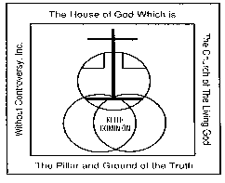Which is the Church of the Living God*

*The Pillar and Ground of the Truth Without Controversy, Inc., Keith Dominion*

P.O. Box 22675, Nashville, TN 37202

Bishop Clary K. Butler, Sr., Chief Overseer

**Deceased List**

“And God shall wipe away all tears from their eyes; and there shall be no more death, neither sorrow, nor crying, neither shall there be any more pain: for the former things are passed away.” Revelation 21:4.

NORTH CAROLINA DIOCESE

**DATE: DIOCESE:**

|  |  |  |  |  |
| --- | --- | --- | --- | --- |
| **MALE**  **OR FEMALE** | **RANK** | FULL NAME | **DATE OF DEATH** | **LOCAL CHURCH** |
|  |  |  |  |  |
|  |  |  |  |  |
|  |  |  |  |  |
|  |  |  |  |  |
|  |  |  |  |  |
|  |  |  |  |  |
|  |  |  |  |  |
|  |  |  |  |  |
|  |  |  |  |  |
|  |  |  |  |  |
|  |  |  |  |  |
|  |  |  |  |  |
|  |  |  |  |  |
|  |  |  |  |  |

NORTH CAROLINA DIOCESE

**Name of Pastor:**

Signature of State Bishop